Bubble Sort
Bubble sort is very simple and easy to implement sorting technique.
Until explicitly stated sorting means ascending order.

Let’s take an example , we have a list of numbers stored in an array :
-2,45,0,11,-9
Logic starts with comparison of first two elements and if the left element is greater than right element, they swap their position.
Comparison proceeds till the end array.
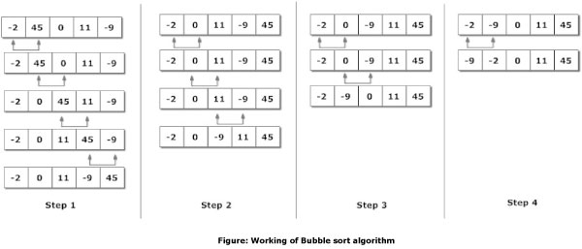

Algorithm
BUBBLE_SORT(A,N): A is an array of values and N is the number of elements.
Repeat for round = 1,2,3,…..N-1
Repeat for i=0,1,2,3…..N-1-round
If A[i]>A[i+1] then swap A[i] and A[i+1]
Return

Program:
void bubble_sort(int[],int);
void main()
{
int A[]={34,15,29,8} ;
int i;
clrscr();
bubble_sort(A,4);
for(i=0;i<=3; i++)
printf("%d\n",A[i]);
getch();
}

void bubble_sort(int A[], int N)
{
int round,i,temp;
for(round=1; round<=N-1; round++)
{
for(i=0; i<=N-1-round; i++) // Every round comparison s reduces
{
if(A[i]>A[i+1])
{
temp=A[i];
A[i]=A[i+1];
A[i+1]=temp;
}
}
}
}

